Note: Include this page only when adding / amending / deleting a document. If using this document as a record, this Revision History page can be omitted.

REVISION HISTORY

Revision no | Date | Description of Changes | Reason for Revision | Revised by | Approved by
1 | 07 Dec 12 | - Add revision history page  - Updated record names in Quality Records section  - Add preparation of PM Plan in the procedure | - Recommendation from Stage 2 audit  - To make document names more descriptive of its function  - Address Q4 2012 IQA observation | CMRojas
2 | Apr. 8, 2016 | Added disclaimer when printing the document | For document control | RCGanal | ARAlacar
3 | Apr. 21, 2017 | - Removed Preventive Maintenance Report from references  - Added Notes for the Thermohygrometer reset | - The Report is no longer relevant  - Recommendation from 2016 audit | ARAlacar | RCGanal
TM-BR-MG- 11 Rev02, 10302015

- Objective
To address potential problems in IT infrastructure before they become failures.
- Scope
This procedure defines the action and responsibilities of the staff of the IT unit to prevent the breakdown of IT infrastructure before they happen. This includes activities from the start of the scheduled preventive maintenance until the time the preventive maintenance report is submitted to the management committee for their review.

- Definition of Terms
PM | Preventive Maintenance

- Procedure Details
RESPONSIBLE | ACTIVITY | INTERFACE
IT Head  Technical Support  Technical Support  Technical Support  Technical Support | 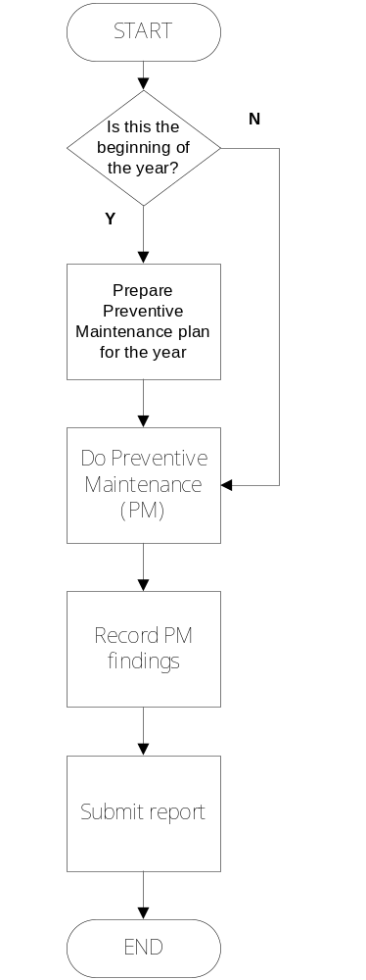 | Preventive Maintenance Plan  Preventive Maintenance Checklist  ThermoHygrometer Log  IT Head

Notes:

- The ThermoHygrometer should be reset regularly to ensure that it is properly calibrated. The schedule for reset is included in the Preventive Maintenance Plan.
- Indicate when the Reset is done in the ThermoHygrometer Log as follows:
 |  | AM | AM |  |  | PM
DATE | DAY | TIME | TEMPERATURE  ------------------Reset------------------ | HUMIDITY | TIME | TEMPERATURE | HUMIDITY
3/31/2017 | Friday | 10:00
3/31/2017 | Friday | 10:00 | 24 C | 32% | 4:00 | 22 C | 31%

- References
- Machine User Manuals
- Preventive Maintenance Plan

- Quality Records
- Preventive Maintenance Checklist

